**Project Name:** Patient Medicine Classification

**Github Link:** https://github.com/projectsforstudents2022/Patient_Medicine_Classification.git

**Why was this project created?**

The majority of drugs function by interacting with host or pathogen proteins. Numerous proteins can be drug targets, and the term "receptor" is only applied when a contact leads to a cascade of signal transmission. An endogenous substance on the surface or within a cell is recognised by and bound by a receptor, which is a molecule or polymeric structure. The exact mechanism of action of several medications is unknown. Meanwhile, the mechanisms of action of some medications have already been identified.

**What problem is it solving?**

Drug categorization serves to guarantee that drug usage is advantageous and safe. But when people use drugs, their bodies' chemistry is altered. Drugs can also be hazardous even when they are intended to be beneficial. Sadly, taking numerous medicines can drastically alter body chemistry, rendering them less effective..

**Entire explanation of project**

* **PROPOSED APPROACH**

The training dataset and testing dataset are separated from the provided dataset. Additionally, the target dataset and the features dataset have been separated from the training dataset and testing dataset. 23,814 training samples are included in both the training features dataset and the training target dataset. Additionally, 3982 testing samples are included in both the testing characteristics dataset and the testing target dataset. The categorical values of the characteristics are converted into numerical values during the data pre-processing step. The null values are then handled. Following the construction of the Random Forest Classifier, the model is assembled and trained.

To illustrate the Mechanism of Action of each medicine, a web application has been created. The Flask framework is being used to create this web application. We separated the patient information based on the patient's gender, symptoms, and blood pressure. A confusion matrix for prediction will be constructed after our model has been tested on a test dataset.

Algorithm for creating next word prediction model :

**Step 1:** Import Libraries & Load Dataset

**Step 2:** Data Cleaning

**Step 3:** Label Encoding

**Step 4:** Build Random Forest Classifier

**Step 5:** Train Model

**Step 6:** Testing & Visualization

* **DATA FLOW DIAGRAM**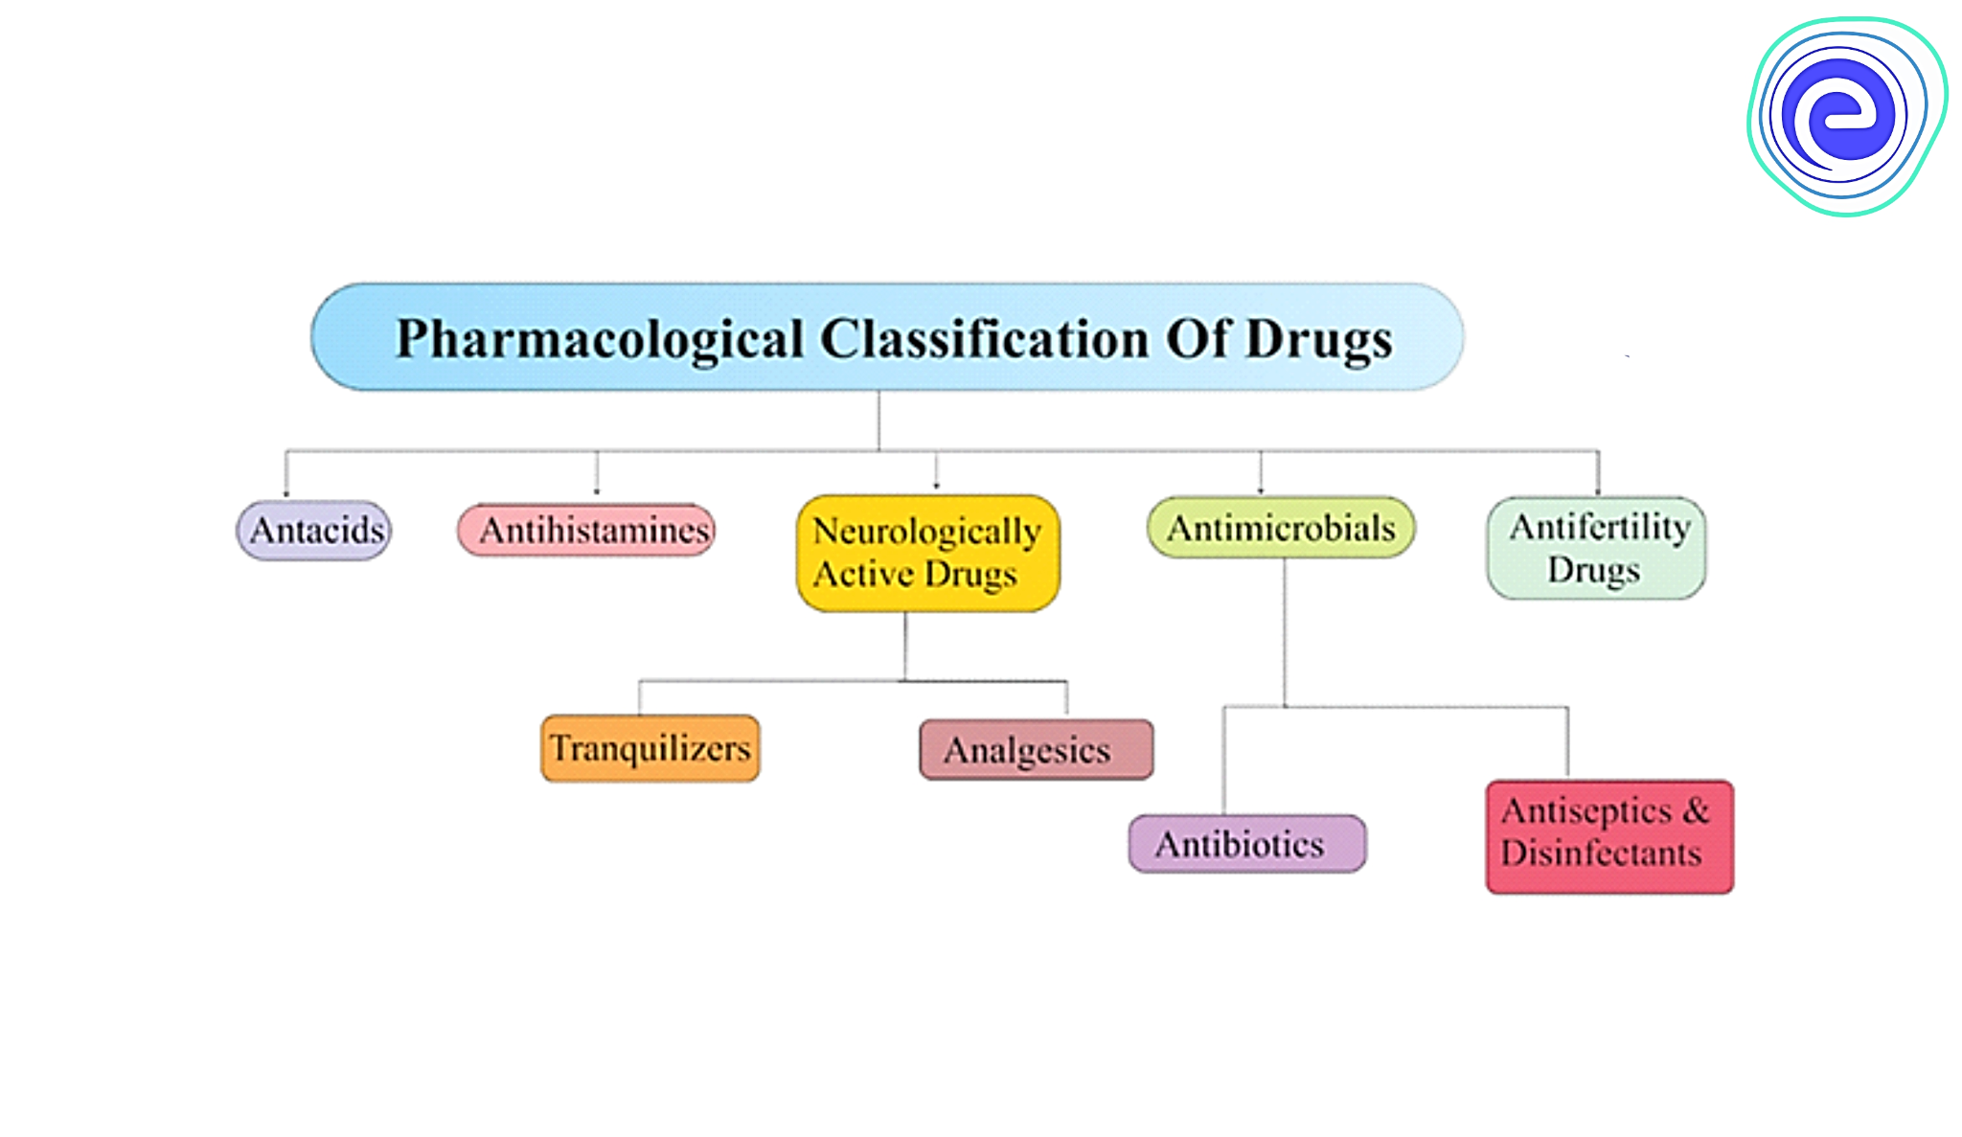
* **RESULT**

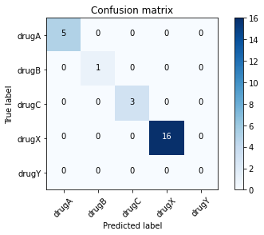

* **CONCLUSION**

Drug discovery can be sped up by understanding the mechanism of action. In this study, machine learning models called Random Forest Classifiers were proposed as a way to forecast a drug's mode of action. The final product includes a scatter plot of the major pharmacological classes. This can aid in the development of novel medications and assist scientists forecast the Mechanism of Action.